FOR IMMEDIATE RELEASE CONTACT: Marie Coolman
Sr. Director of Publicity and Communications, Bloomsbury USA
646.307.5579 / Marie.Coolman@bloomsbury.com

SPECTRUMS
Our Mindboggling Universe from Infinitesimal to Infinity
by David Blatner

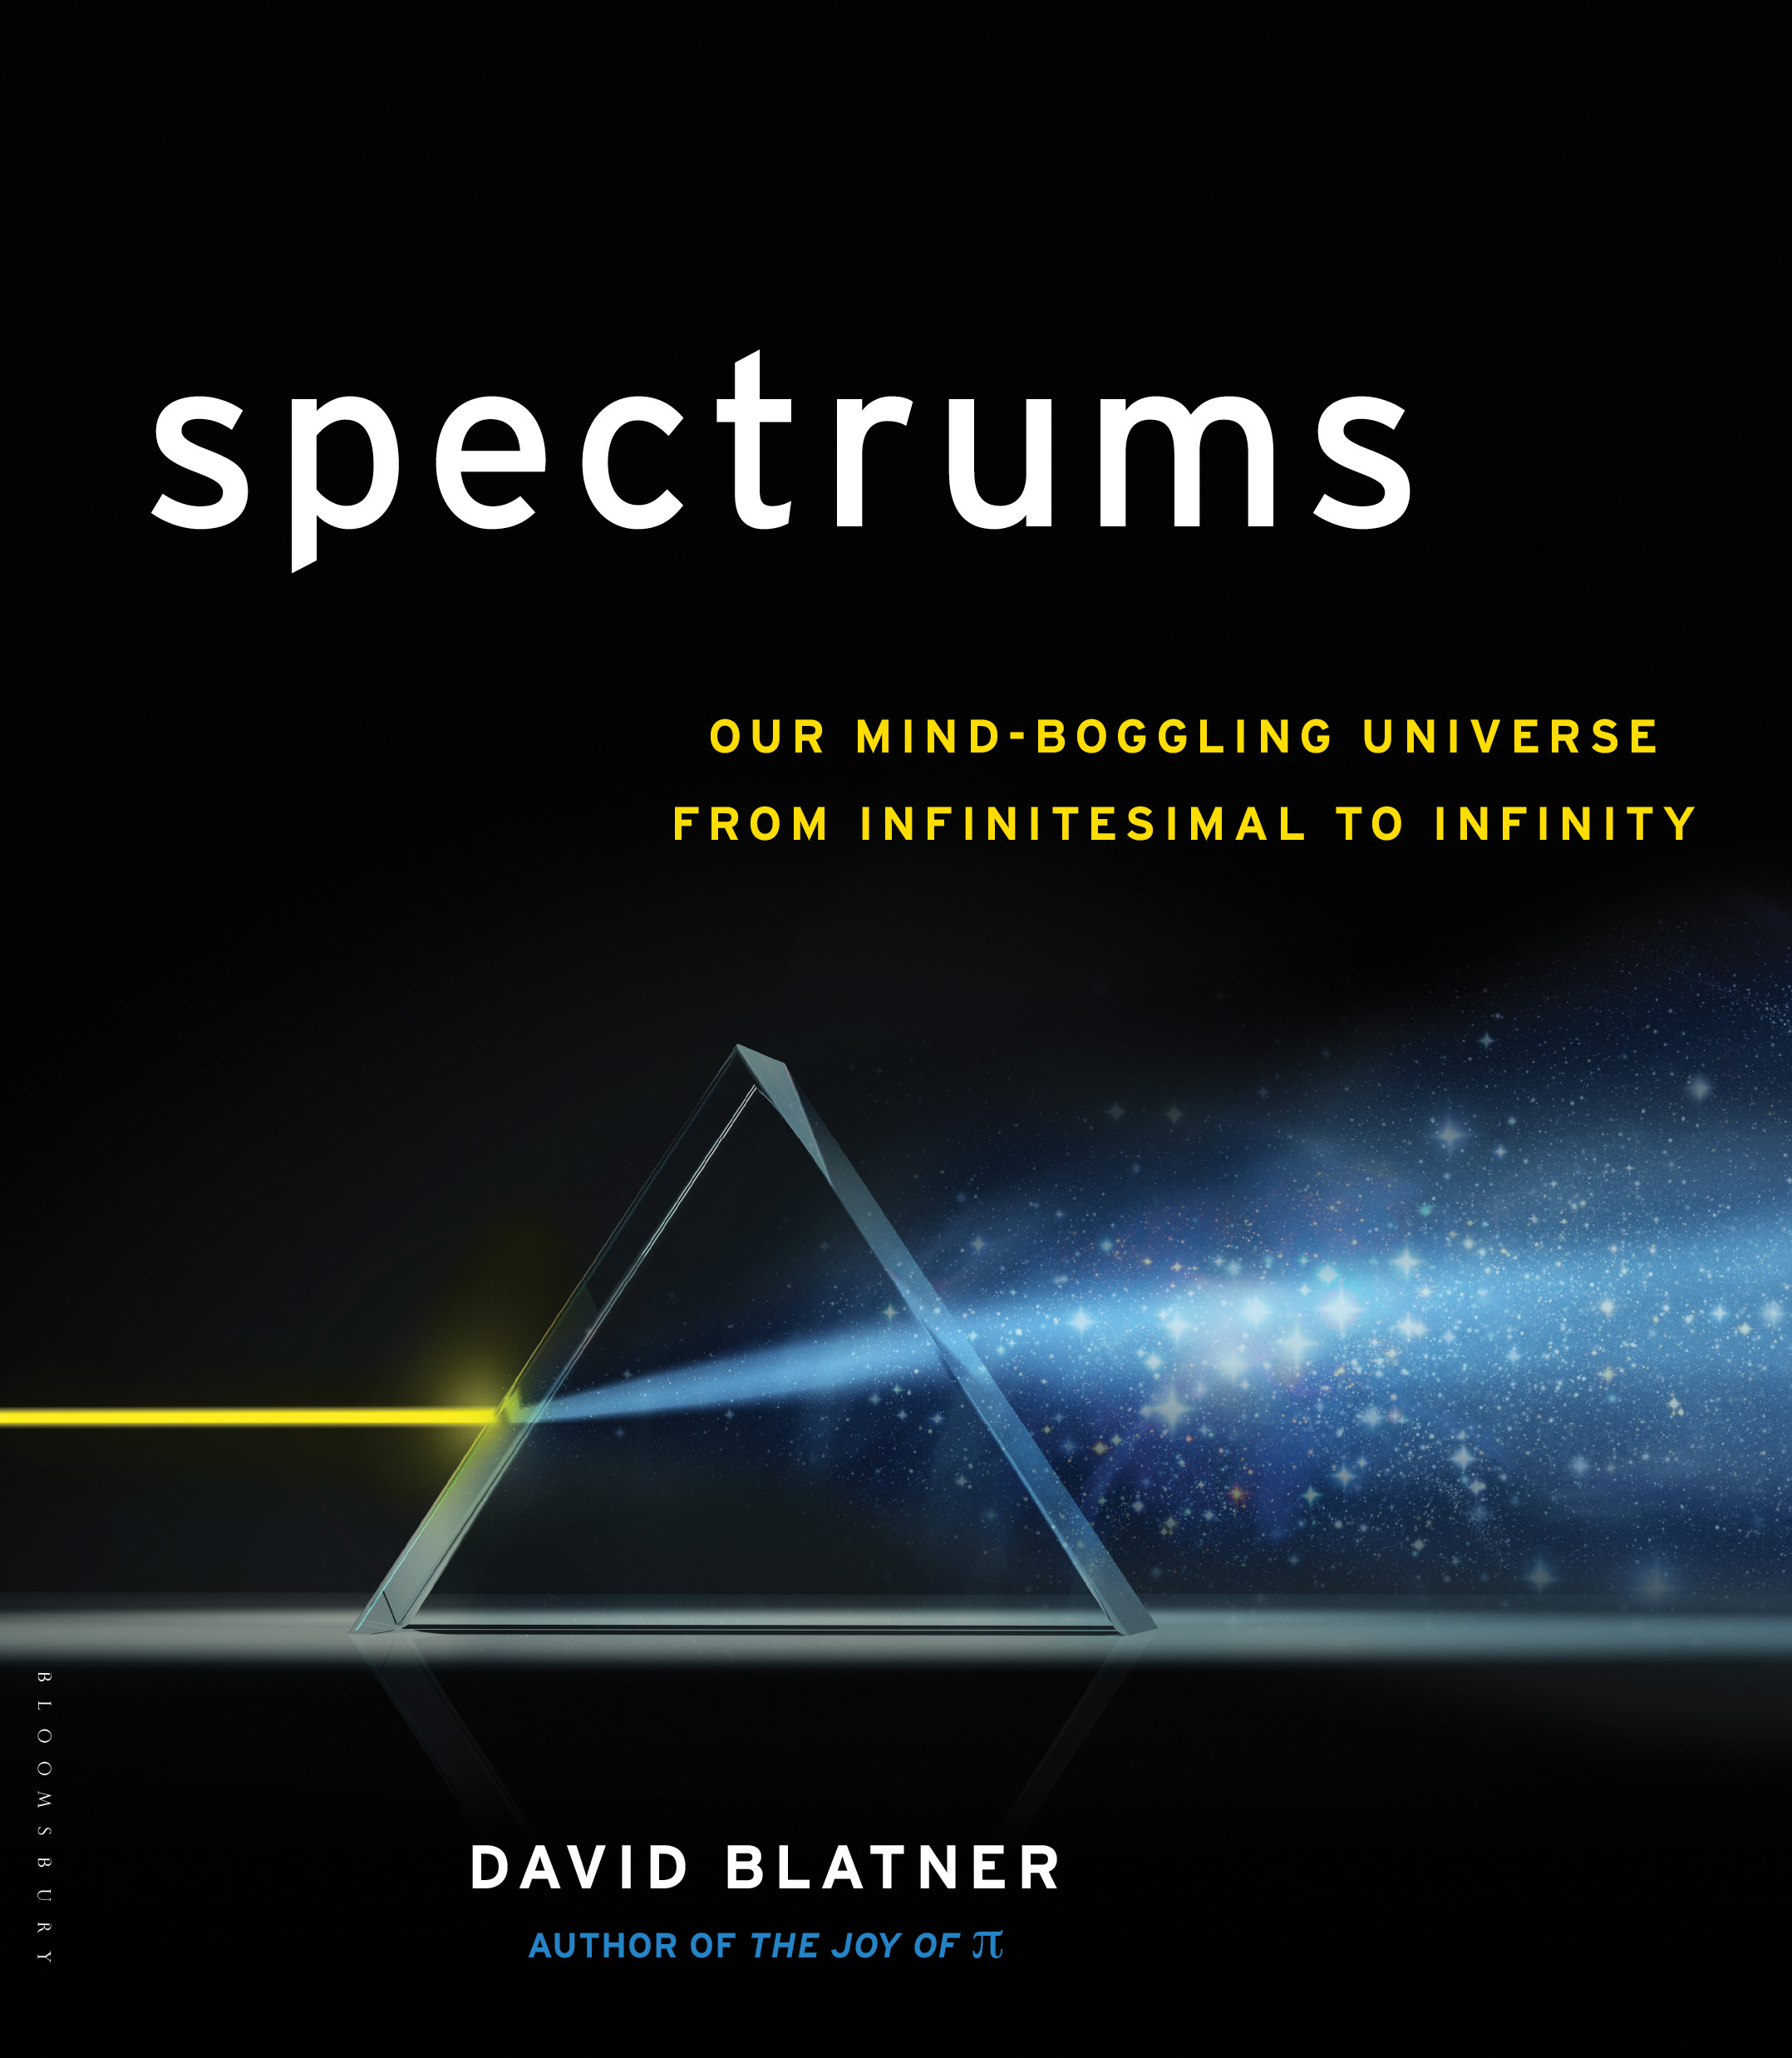

"I love this book! The writing and imagery are beautiful, as is the layout. Blatner is a witty and
awesome tour guide to areas beyond our perceptual horizon, from speeds at which hummingbirds fly,
to cell phone ring tones too high for adults to hear, to mountains taller than Everest but which begin underwater. This is an indispensable manual if we want to grok—deeply understand—our world."
—Dr. Robert P. Crease, author of World in the Balance: The Historic Quest for an Absolute System of Measurement, Professor of Philosophy, Stony Brook University

“Enthralling and beautifully written. It builds a new 21st century perspective on STEM (science, technology, engineering, mathematics) for both the curious young and the well-educated adult.”
—Ed Feigenbaum, National Academy of Engineering, Former Chief Scientist, US Air Force

“Spectrums is a mind-expanding perspective shift that evokes a deep reverence for reality
at all scales, and provides inspiration no matter where you fall on the spectrum of
science and religion.”
—Rev. Michael Dowd, author of Thank God for Evolution

“This thoroughly researched book will engage all readers, from curious twelve-year olds to every
adult who delights in learning something new. Blatner stretches our imaginations inward toward
the infinitesimal and outward toward the infinite—with lots of engaging examples, comparisons,
and metaphors. Read it with wonder and awe!”
—Nils Nilsson, Stanford University Kumagai Professor of Engineering (Emeritus), Department of Computer Science

In his colourful new book, SPECTRUMS: Our Mind-Boggling Universe from Infinitesimal to Infinity (Walker & Company hardcover and eBook; November 13, 2012), award-winning author David Blatner begins with the premise that we humans can only observe a narrow slice of the world around us. But the universe exists far beyond what we can see, hear, feel or touch—and often, what we can even comprehend. From the very large to the very small, Blatner illuminates the full range of six spectrums: Numbers, Size, Light, Sound, Heat, and Time, to create a truly awe-inspiring catalog of our place in the universe.

A few spectrums to consider:

- The distance from the surface of the earth to the International Space Station is almost exactly the same distance as the train ride from Manhattan to Washington, D.C.
- There are more insects in a single square mile of good, fertile soil than there are human beings on the planet.
- Each cell in the human body contains more atoms than there are stars in the Milky Way.
- The only animal that can see both infrared and ultra violet light is the goldfish.
- The difference between a million and a trillion: A million seconds is just a week and a half; a trillion seconds is more than 30,000 years.

There is actually very little in the larger universe that is tangible. It’s not an easy task to stretch the mind to encompass both billions of years and billionths of seconds, the distance to Jupiter, and the size of a proton; the tiny waves of visible light and gargantuan but invisible radio rays; or the freezing point of Helium and the heat generated by the blast of an atom bomb. But, exploring these far-reaching spectrums gives us fascinating perspective on our small but not insignificant place in the universe. With easy-to-read, engaging, and insightful observations, and illustrated by a wealth of photographs, sidebars and diagrams, Blatner helps us understand intuitively the variety of spectrums we encounter constantly, making our daily lives richer and more meaningful through greater appreciation of the bizarre and beautiful world in which we live.

Blatner also explores our history of understanding each spectrum and of the men and women who helped uncover these fascinating extremes. He brings us up-to-date on the current thinking about the limits (or lack of limits) of where we might still yet go. As he says, our knowledge also exists on a spectrum, one we can’t quite see the edges of. “A cheerful, comprehensible…review of the material universe,” writes Kirkus Reviews, Spectrums is one of the most entertaining science books in years.

ABOUT THE AUTHOR:

David Blatner is internationally known for his popular science books, including The Joy of Pi and The Flying Book, and for his award-winning books for graphic designers. He lectures worldwide on electronic publishing. More than a half-million copies of his books are in print in fourteen languages. He lives with his family in Seattle, Washington. Follow him on Twitter @dblatner.

Walker & Company / SPECTRUMS / Publication Date: NOVEMBER 13, 2012 / $25 / 183 p / Hardcover / ISBN: 080-2-71770-5 / www.spectrums.com

Reviewers are kindly requested to send tear sheets to the publisher:
Attn: Publicity Department, Bloomsbury USA, 175 Fifth Avenue, New York, NY 10010

