Some Surprising Facts From

SPECTRUMS
Our Mindboggling Universe from Infinitesimal to Infinity
by David Blatner

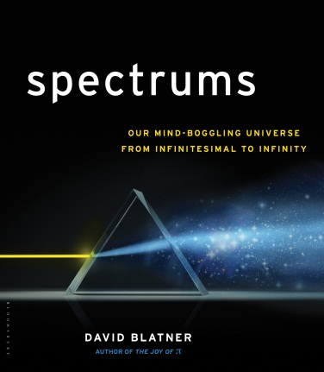

NUMBERS:
- There are about 16 sextillion stars throughout the known universe—that’s a 16 with 21 zeros after it! This is also about how many molecules you’d find in just ten drops of water.
- There are more insects in a single square mile of good, fertile soil than there are human beings on Earth.
- You can imagine a “billion” like this: a dime is about one-billionth of the diameter of the Earth; half the width of your smallest finger is about one-billionth the distance from New York to Los Angeles.

SIZE:
- There are more bacteria living inside each of us than the number of cells in our own body. (That means we are more “them” than “us”!)
- If Earth were the size of the period at the end of this sentence, the moon would be about one half-inch away, and the Sun would be about the size of a child’s fist and 20 feet away.
- Few Americans realize that the first president to discuss switching the country to metric measurements was George Washington!
- How big is our solar system? If you shrunk everything down so that the Earth was the size of a grain of salt, the solar system would be over three football fields wide.

LIGHT:
- Microwaves heat with light, but the light waves are thousands of times longer than the waves we can see. So light waves can escape through the little holes in the microwave door, but microwaves are too big to get out.
- Customs officials looking for nuclear material with gamma ray detectors are often stymied by bananas and Brazil nuts because they have higher than average quantities of naturally occurring radioactive material. It gives new meaning to getting high energy from eating fruits and nuts!
- The only animal that can see both infrared and ultraviolet light is the goldfish.

SOUND:
- Our ears are so sensitive that we can detect sound when air molecules move even a millionth the size of the smallest dust speck you can see.
- It takes five seconds for a very loud sound to travel a mile; three to travel a kilometer.
- Very low frequency sound, below what humans can hear, can make people feel an eerie sense of foreboding and cause the eye to see ghostly apparitions.

HEAT:
- The North American wood frog can literally freeze solid, stopping its heart and breathing until spring, when it thaws and hops away.
- The colder the air, the less moisture it can hold. That’s why mountain ranges in temperate areas receive far more snow than the north or south poles. The Antarctic is essentially a desert, with extremely dry air and less precipitation than Phoenix, Arizona!
- The record for hottest temperature in the universe was recently broken by CERN in Geneva: Over five trillion Kelvin (9,000,000,000,000°F), causing atoms to break down into subatomic particles called a quark-gluon “soup.”

TIME:
- In the time it takes for you to read this sentence, our planet has travelled 185 miles around the sun, 42 babies have been born, and your laptop computer could have calculated 40 million different chess moves.
- Time doesn’t march forward at the same rate everywhere. Gravity and speed literally change how fast time goes by, so you literally age a tiny bit faster when you climb a ladder. (Atomic clocks have to adjust for this even when they’re on different floors of the same building.)
- Even if you could travel “Warp 7” (which SciFi fans will immediately recognize as 656 times faster than the speed of light), it would still take more than 2 days to get to the nearest star beyond our sun, and 152 years to get across our galaxy.

CONTACT: Marie Coolman / Senior Director of Publicity and Communications /Bloomsbury / 646.307.5579 / Marie.Coolman@bloomsbury.com / www.walkerbooks.com

www.spectrums.com

